**Module 4**

**Assignment 1**

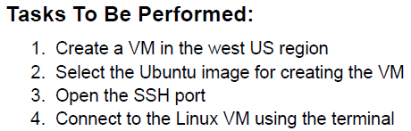

1. Go to Virtual Machines in Azure Portal and Create.
2. Create a Resource Group in the West US Region.

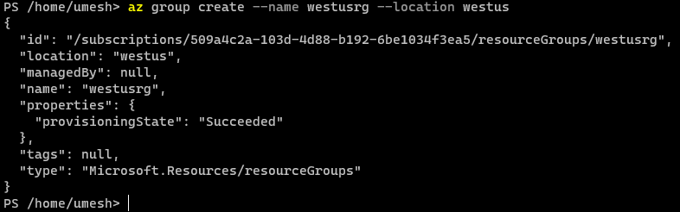

1. Create a Virtual Machine.

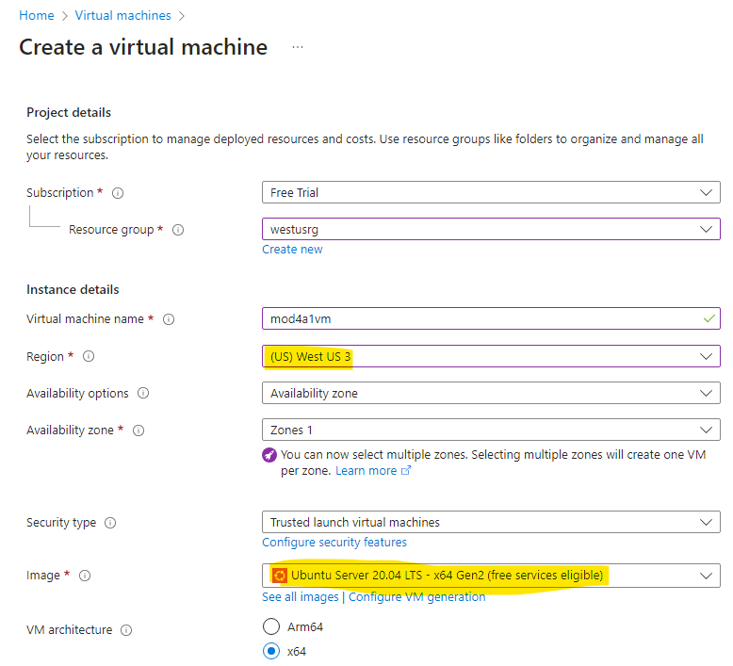

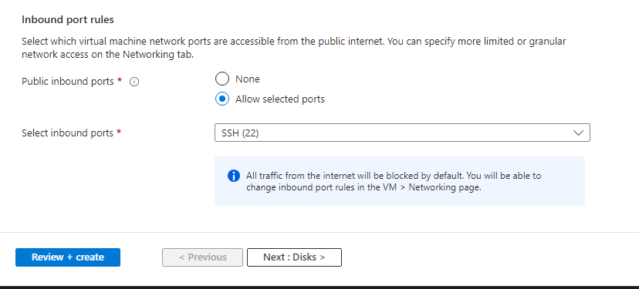

1. Connect to the VM using Public IP.

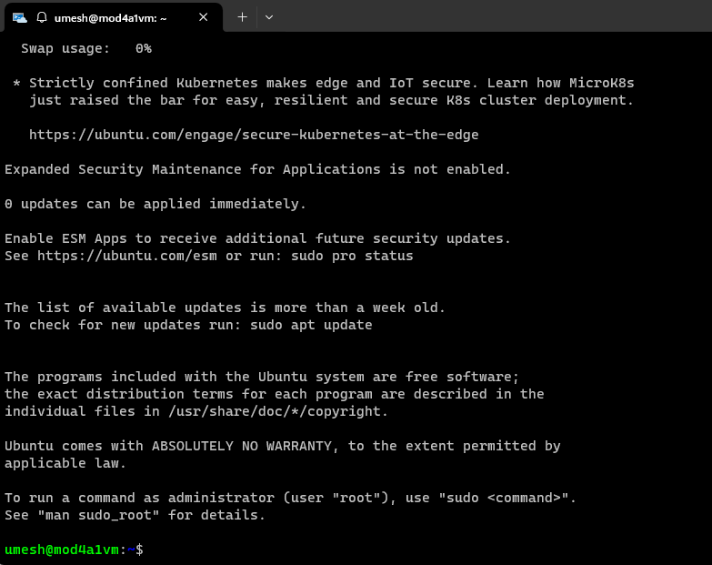

**Assignment 2**

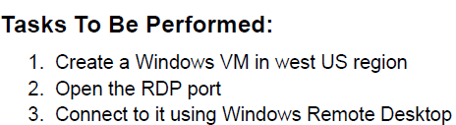

1. Create a Windows VM. Follow same step as Assignment 1.

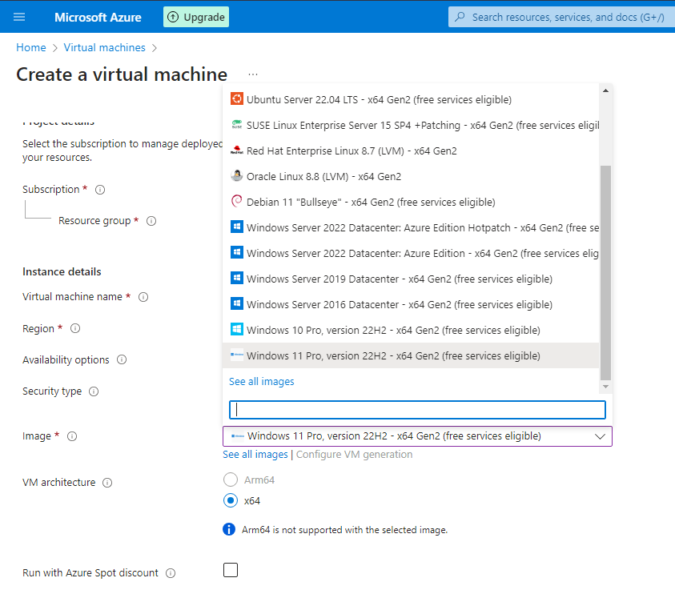

1. Review and Create it. Once deployed, copy the Public IP and open Remote Desktop Connection app from your local machine and connect via IP.

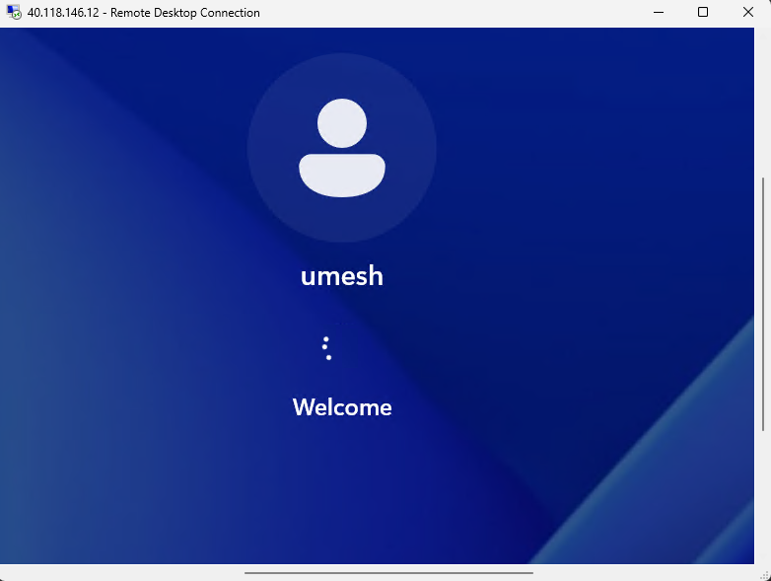

**Assignment 3**

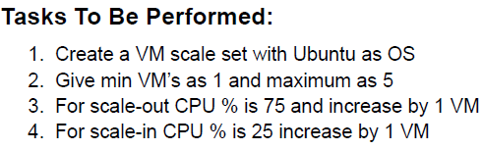

1. Proceed to create VM, and create Virtual machine scale set in the process.

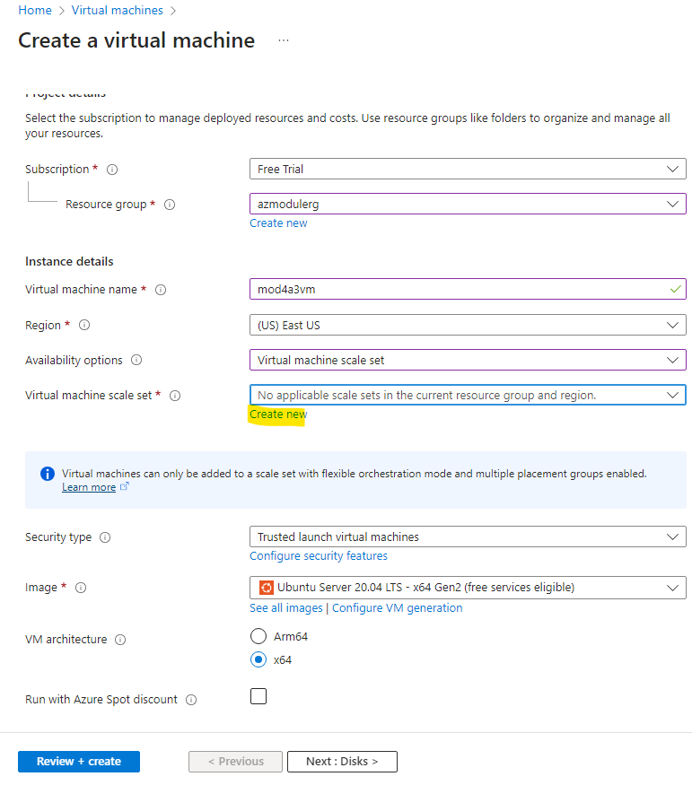

1. Create the scaling method for the Scale Set.

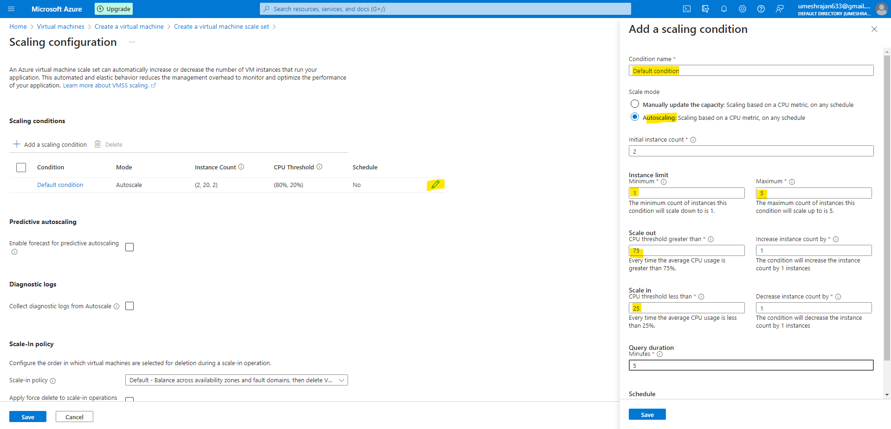

1. Review and Create the VM and test the scaling.

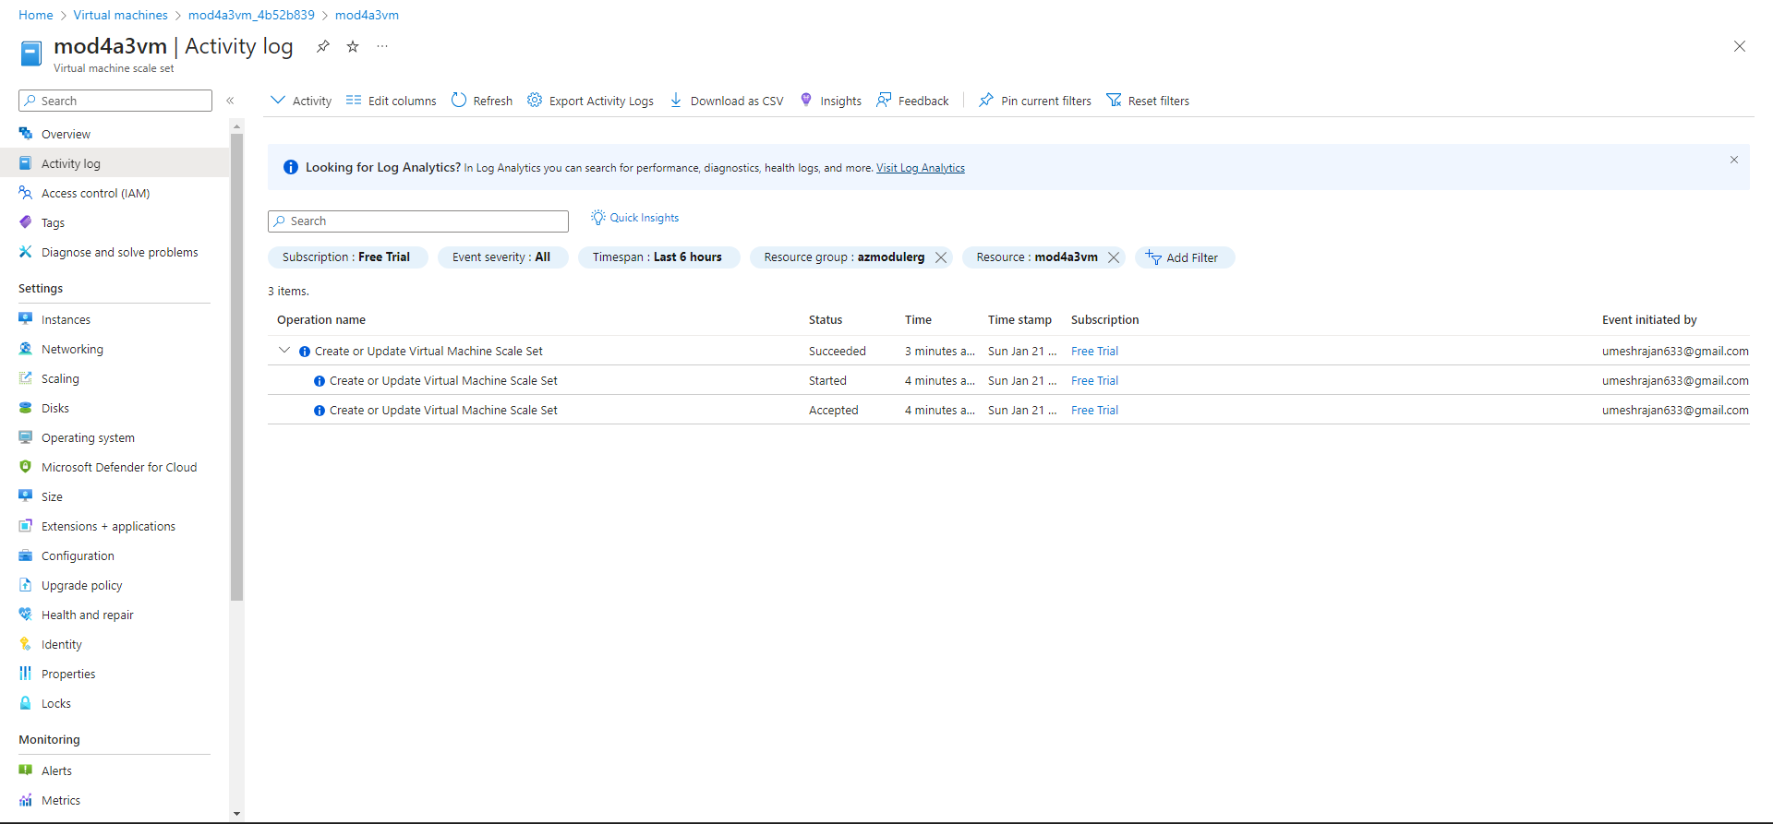

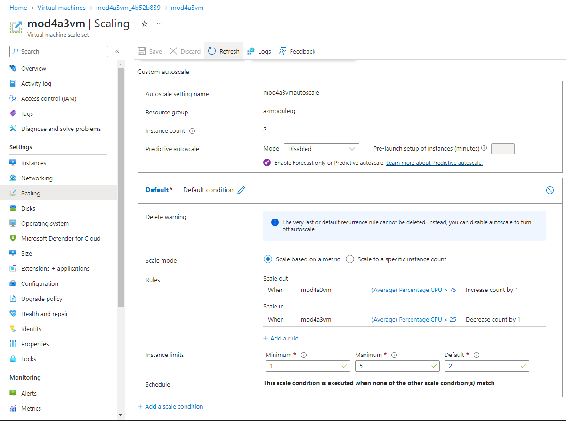

**Assignment 4**

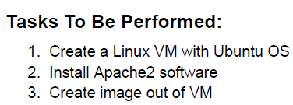

1. Create VM as show above in the above assignment. Once created, connect to the VM.
2. Login to the VM.

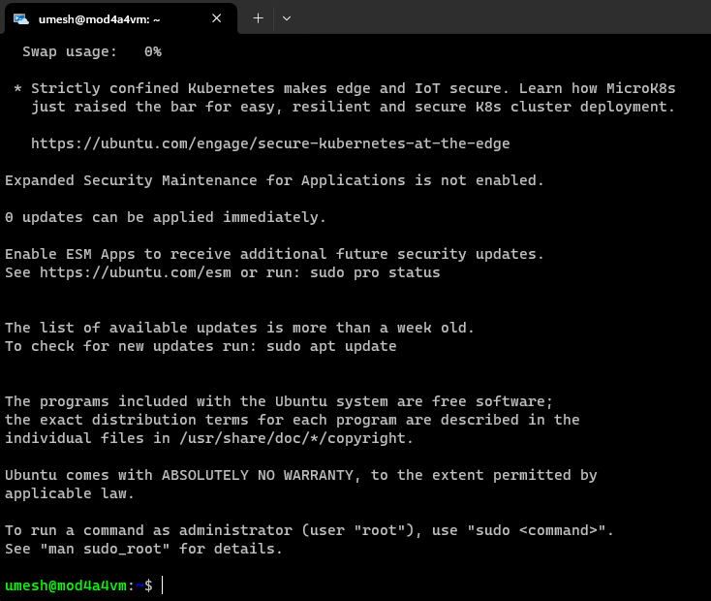

1. To install apache2, pass the command : sudo apt-get install apache2 -y

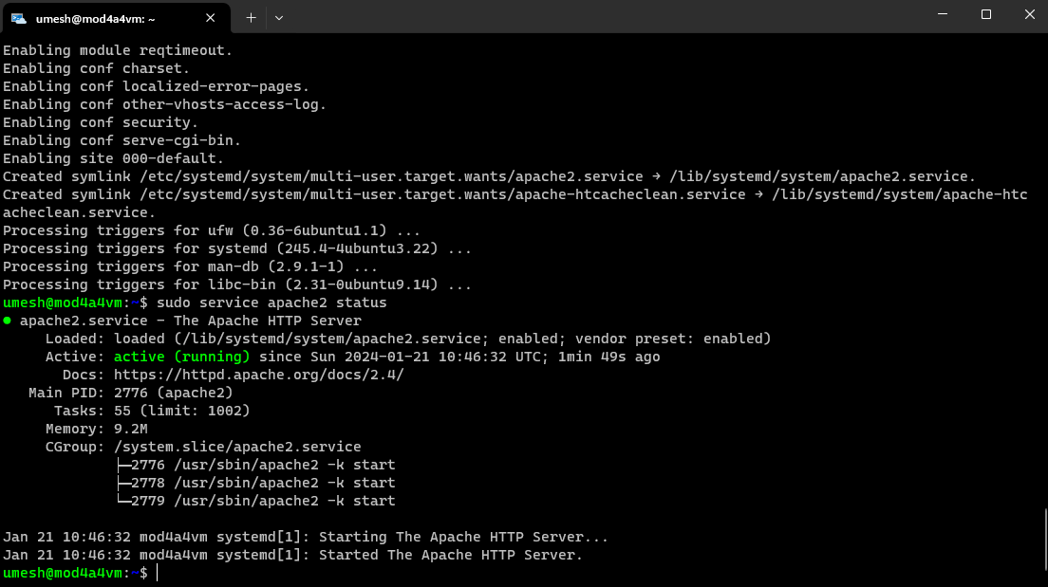

1. Verify by visiting the public ip.

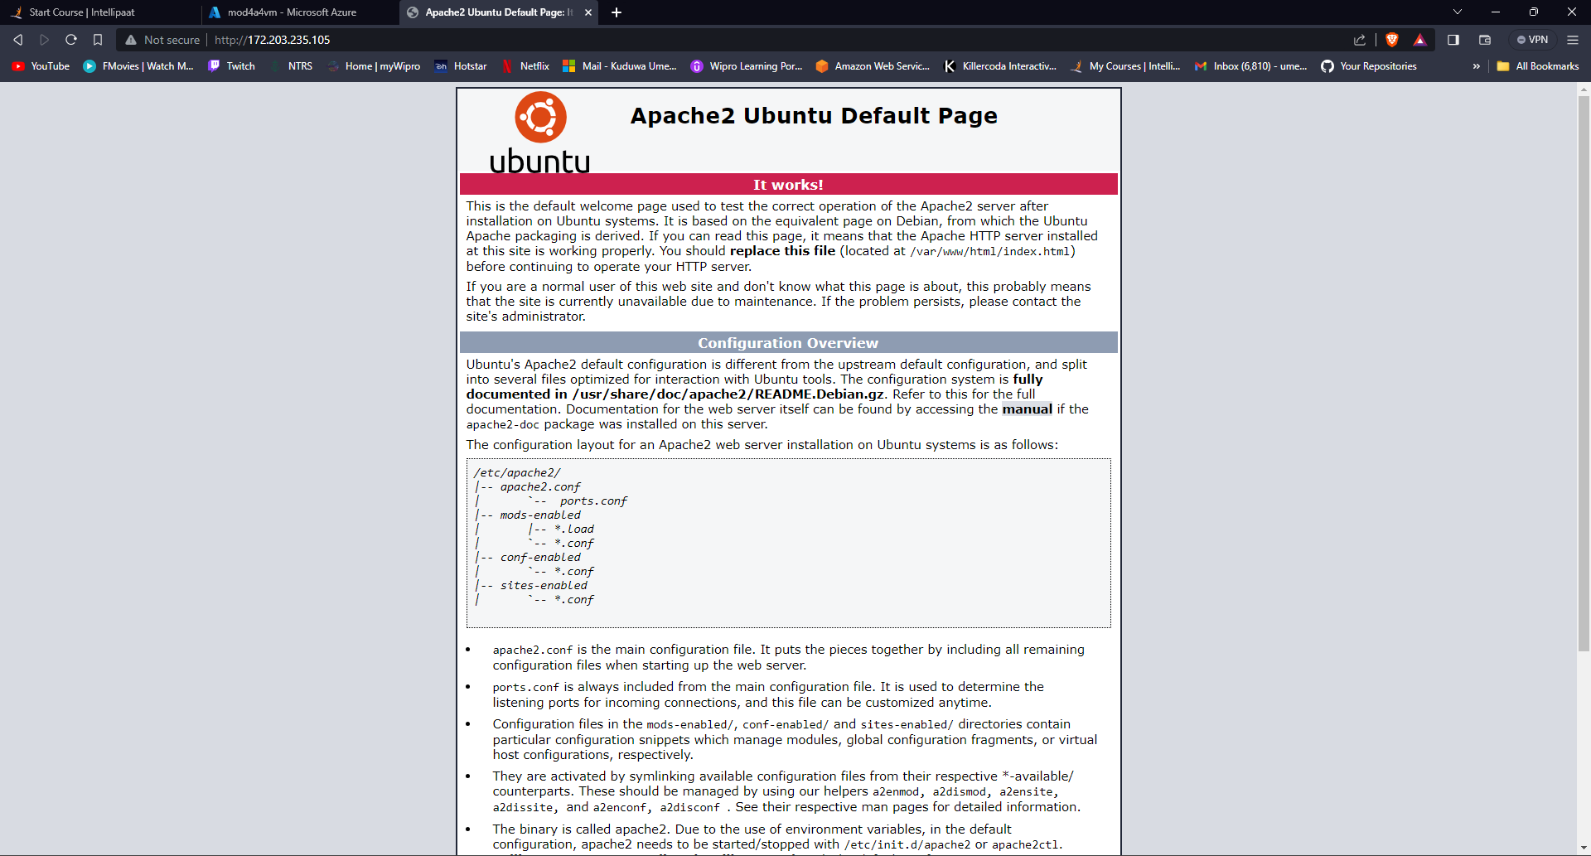

1. Once verified, go to overview of the VM and choose Capture.

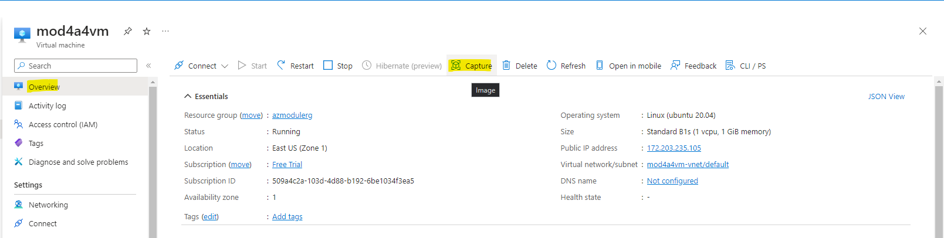

1. Fill all the details and create.

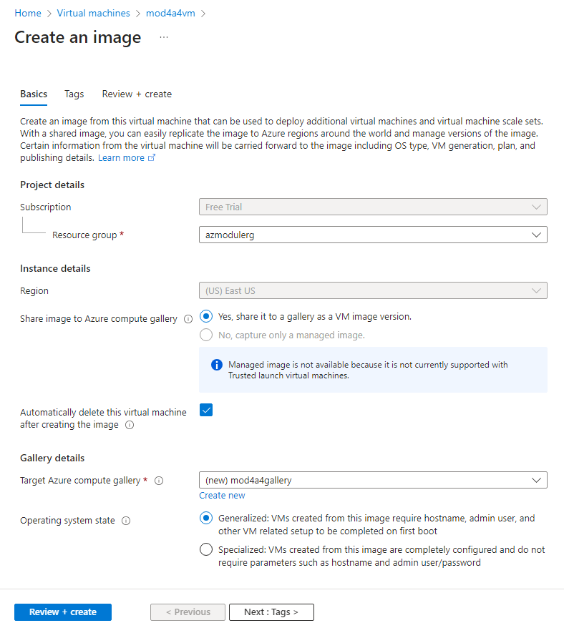

1. Once created, verify by launching a VM and selecting the OS.

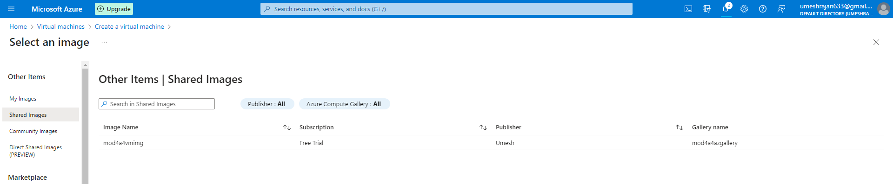

**Assignment 5**

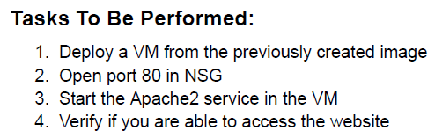

1. Create a VM from the Image Created in the previous assignment.
2. The port 80 is already open.
3. To start the apache service : sudo service apache2 start and sudo service apache2 status

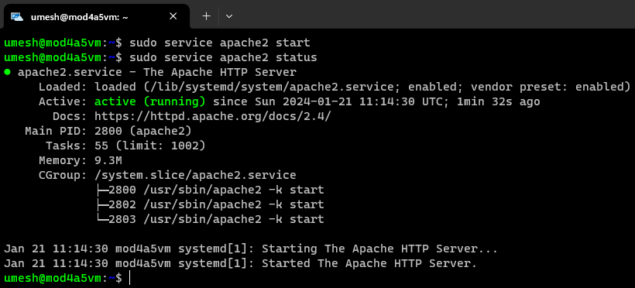

1. Verify by visiting the website.

